1. Nickels
2. 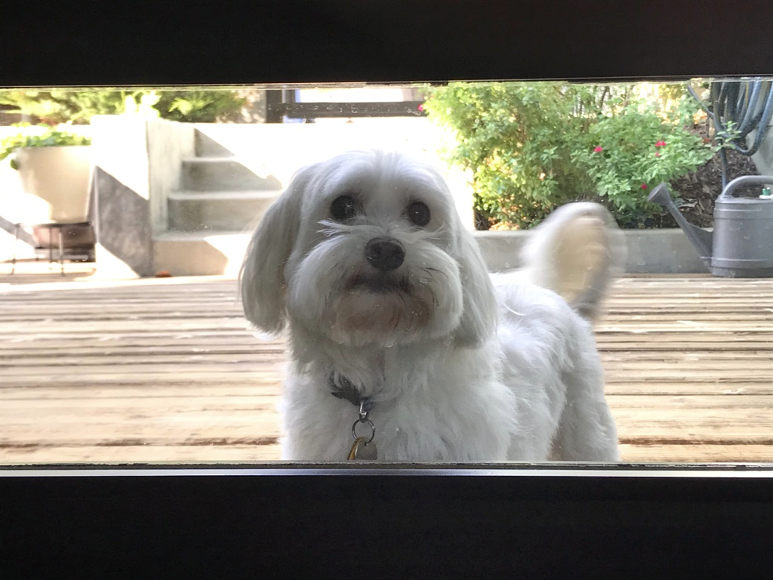
3. Nickels.png
4. A small white dog, wagging his tail in a window, with a garden in the background.
5. Nickels was adopted from Ohio in 2010. He turned 13 years old in June 2023, which he celebrated with a Taylor Swift themed birthday party. Nickels often travels with his family; he has been to over ten states. He has lived in Illinois and California. Nickels is a very unique dog- he is allergic to meat. His favorite word is “present.” His one true joy is receiving and opening gifts with his family.
6. In 2020, Nickels’ brought home a new dog: Socks. Socks is potentially the villain in Nickels’ life. He destroys Nickels’ favorite toys and is highly allergic to peanut butter, which means Nickels now rarely gets his favorite treat! However, when you find them sharing a dog bed, you wonder if the sibling rivalry is all a facade.

For the next four pictures you can just put the names of the files, you don't have to include the files in this drive, but you do need to add them to the proper Google Drive.

1. **Photo Gallery – (Just write Photo Gallery)**
2. Nickels_Adoption_Day.png
3. Small white puppy sitting by a child's shoe.
4. Nickels_Puppy.png
5. Fluffy white puppy laying on woodfloor.
6. Nickels_Glasses.png
7. Small white dog with a pair of gray glasses balanced on his face.
8. Nickels_and_Socks.png
9. Small white dog and black & white dog laying next to each other on a beige towel.
10. **Likes – (Just write Likes)**
11. Plush toys
12. Wrapping paper
13. Dog parks
14. Maddie House